Practical No. 10
Aim : 3) WAP to create a set, add items in a set and remove items from set.

Name : Danish Altaf Solkar | Class : CO - B
Enrolment no. : 24111590805 | Batch : 2

Code :-
s = {10, 20, 30, 40, 50}

print("Set:", s)

s.add(60)
print("After adding element:", s)

s.remove(10)
print("After removing element:", s)

OUTPUT :-
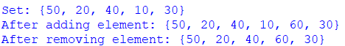

Aim : 5) Write a python program to find the length of a set.

Code :-
s = {10, 20, 30, 40, 50}

print("Set:", s)
print("Length of set:", len(s))

OUTPUT :-
